**Algebra 2**

Transformation of Functions (Khan B-3)

The function f(x) will reflect over the ‘X’ axis if: **- f(x)**

The function f(x) will reflect over the ‘Y’ axis if: **f(-x)**

**Even / Odd functions**

The function is **even** if: **f(x) = f(-x)**

Example:

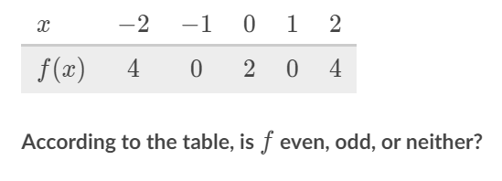

Let’s look at ‘x’ if x = 2 f(x) → f(2) = 4 f(-x) →f(-2)= 4 -f(x) → -f(2)= -4

Therefor we see f(x) = f(-x) which is an even function.

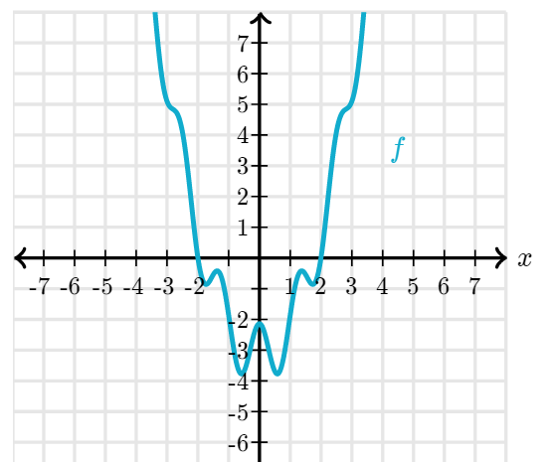

Let’s look at ‘x’ if x = 3

f(x) → f(3) = 5

f(-x) →f(-3)= 5

-f(x) → -f(3)= -5

Therefor we see f(x) = f(-x) which is an even function.

The function is **odd** if: **f(x) = - f(x)**

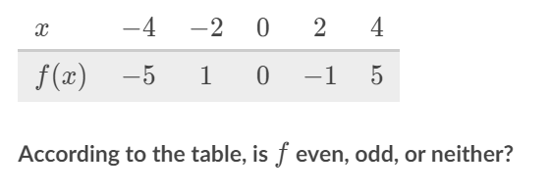

f(x) → f(2) = -1 f(-x) →f(-2)= 1 -f(x) → -f(2)= - -1 or 1

Therefor we see f(-x) = -f(x) which is an odd function.

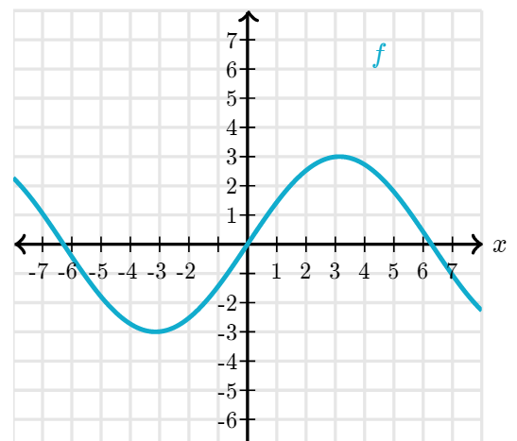

f(x) → f(3) = 3

f(-x) →f(-3)= -3

-f(x) → -f(3)= - 3

Therefor we see f(-x) = -f(x) which is an odd function.